7 epochs, dropout from scratch

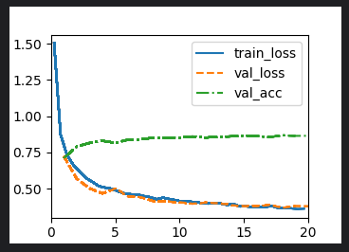

20 epochs, with dropout from scratch

The validation accuracy seems to stead out, maybe slightly less than with a lower number of epochs?